Gap Analysis:
Person- and Family-Centred Care, May 2015
Work Sheet

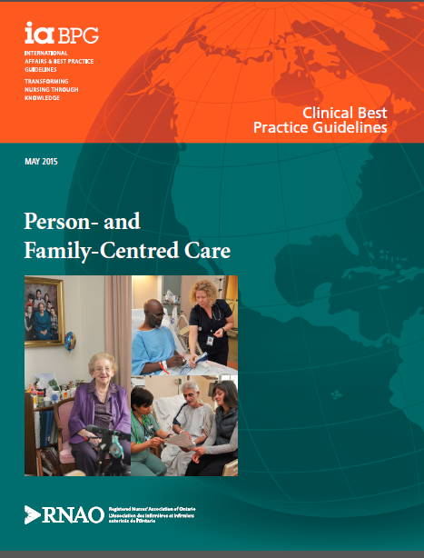

This guideline can be downloaded for free at:
http://rnao.ca/bpg/guidelines/person-and-family-centred-care

Leading Change Toolkit
Leading Change Toolkit™ | RNAO.ca

Date Completed:
Team Members participating in the Gap Analysis:
Completion of this gap analysis allows for the annual comparison of your current practice to evidence-based practices as regulated by the MOHLTC per Fixing Long-Term Care Act, 2021 at https://www.ontario.ca/laws/statute/21f39
& O. Reg. 246/22: GENERAL (ontario.ca)

RNAO Best Practice Guideline Recommendations | Met | Partially Met | Unmet | Notes  (Examples of what to include: is this a priority to our home, information on current practice, possible overlap with other programs or partners)
Practice Recommendation: Assessment
1.1 Establish a therapeutic relationship with the person using verbal and non-verbal communication strategies to build a genuine, trusting, and respectful partnership.
(Level III Evidence)
1.2 Build empowering relationships with the person to promote the person’s proactive and meaningful engagement as an active partner in their health care.
(level Ia evidence)
1.3 Listen and seek insight into the whole person to gain an understanding of the meaning of health to the person and to learn their preferences for care.
(level 1a evidence)
1.4 Document information obtained on the meaning and experience of health to the person using the person’s own words.
(level V evidence)
Practice Recommendation: Planning
2.1 Develop a plan of care in partnership with the person that is meaningful to the person within the context of their life.
(level Ia evidence)
2.2 Engage with the person in a participatory model of decision making, respecting the person’s right to choose the preferred interventions for their health, by:
1) Collaborating with the person to identify their priorities and goals for health care;
2) Sharing information to promote an understanding of available options for health care so the person can make an informed decision; and
3) Respecting the person as an expert on themselves and their life.
(level Ia evidence)
Practice Recommendation: Implementation
3.1 Personalize the delivery of care and services to ensure care is not driven from the perspective of the health-care provider and organization, by collaborating with the person on:
1) Elements of care;
2) Roles and responsibilities in the delivery of care; and
3) Communication strategies.
(level Ia evidence)
3.2 Partner with the person to tailor strategies for self-management of care that are based on the person’s characteristics and preferences for learning.
(level V evidence)
Practice Recommendation: Evaluation
4.1 Obtain feedback from the person to determine the person’s satisfaction with care and whether the care delivered was person-and family-centred.
(level Ia evidence)
Education Recommendation
5.1 Educate health-care providers at a minimum on the following attributes of person- and family-centred care to improve the person’s clinical outcomes and satisfaction with care:
1) Empowerment;
2)Communication; and
3) Shared decision making.
(level Ia evidence)
5.2 Educational institutions incorporate this Guideline into the curricula for nurses and, as appropriate, for other health-care providers.
(level V evidence)
System, Organization, and Policy Recommendations
6.1 Create an organizational culture that exemplifies its commitment to person- and family-centred care by:
1 1) Demonstrating leadership and commitment to this approach to care;
2 2)Involving the person in co-designing health programs and services; and
3) Building healthy work environments for all health-care providers.
(level V evidence)
6.2 Design an environment that demonstrably improves the person’s experience of health care by:
1) Creating healing environments;
2) Being flexible and partnering to personalize care routines;
3) Improving access to care and services;
4) Enhancing the continuity and coordination of care and services during transitions; and
5) Providing continuity of caregivers.
(level V evidence)
6.3 Collect continuous feedback from the person to determine whether their experience with health care and services was person- and family-centred, and utilize this feedback to make improvements at all levels of the health system.
(level III evidence)
6.4 Government agencies and regulatory bodies must monitor, measure, and utilize information from organizations regarding the person’s experience of health care to improve health-system performance.
(level Ia evidence)

